**Ollama beginnersworkshop**

Sensemakers ollama meetup 29 May and 19 June  
Github Michiel: [www.github.com/MichielBbal/ollama](http://www.github.com/MichielBbal/ollama)

We recommend you also look at the Ollama Basics tutorial before starting this one!

**Preparation**

For this workshop we assume the following has been downloaded/installed on your laptop;

* **Ollama** Download and install Ollama via www.ollama.com (Mac / Windows / Linux)
* **On your laptop, open a terminal (Command Line Interface)**. On Windows you can find it by typing “” or “prompt” in the searchbox. Then you can ask Ollama to install and run AI Models for you by typing at the prompt:
  + ollama run tinyllama for **TinyLlama**

After installation is completed start chatting with the model by typing your questions at the prompt (see ollama basics tutorial). NB: Allways end Ollama *with* CTRL+C or /bye or /exit *before* you start running or working with a new model.You can then start downloading the other models:

* + ollama run mistral for **Mistral**type /bye after prompt before downloading the next model:
  + ollama run llava for **Llava**
* **Python** Download & install from Python.org
* **Visual Studio Code** Download & install from <https://code.visualstudio.com/>
  + Launch Visual Studio (VS), select extensions, type “python” in the search box and install python within VS
  + 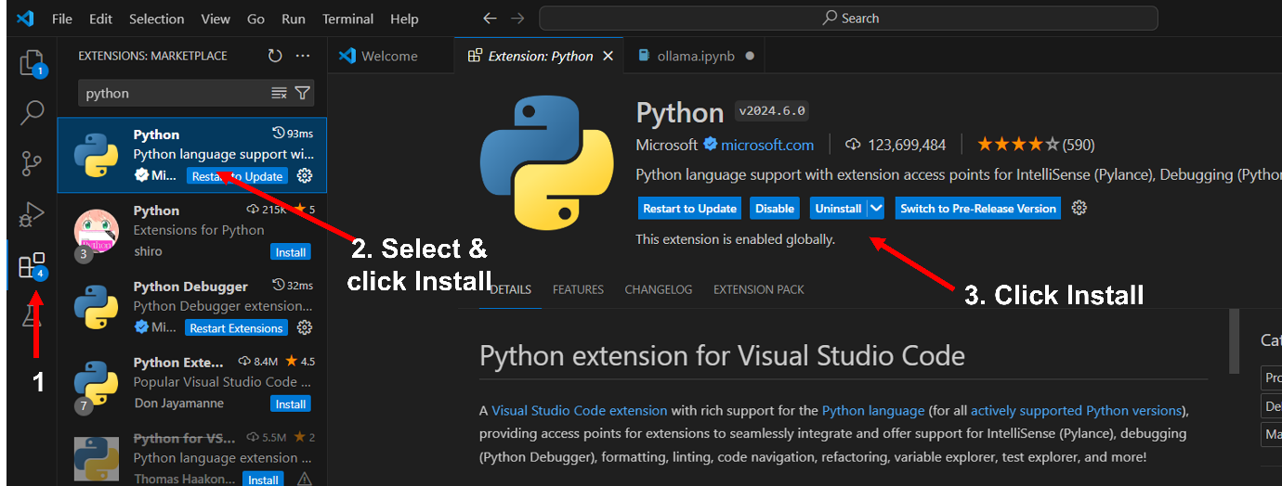Do the same to install the Jupyter extension (to run the notbooks that Michiel prepared for us).
* Now go to the github from Michiel to get all the workshop materials, <https://github.com/MichielBbal/ollama>

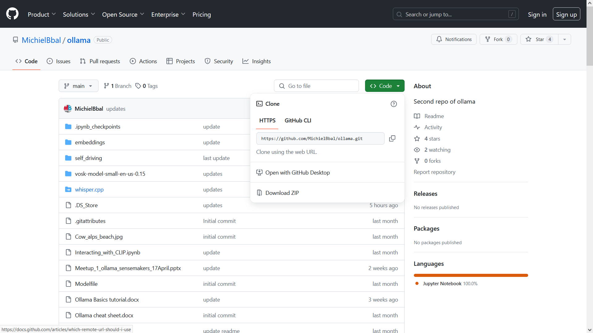

Press the green code-button and select ‘download zip’. Download Zip and extract the files. Remember the name of the folder/directory where the extracted files will be saved!

**Getting started with RAG: Retrieval Augmented Generation**

Now you have all necessary software and files in place, you can start with the first Jupiter Notebook.

Start Visual Studio (VS), select ‘File’ then ‘Open Folder’ go to the directory where the copy of Michiel’s github was saved and select the folder ‘ollama-main’. Now the folder and it’s content are accessible within Visual Studio.

**Please be aware that if you haven’t gone through the steps of the basics tutorial, you need to run the notebook ‘ollama.ipynb’ first! Please accept when it asks you to install something about a kernel😉**When you move your mouse at the left side of every step, a PLAY button pops up, press it and wait till the installation is done for this step and then move on to the next (also see Ollama basics tutorial!!).

Now select the Jupiter Notebook prepared for this second workdhop, it’s called: ollama_RAG_basics_from_scratch.ipynb

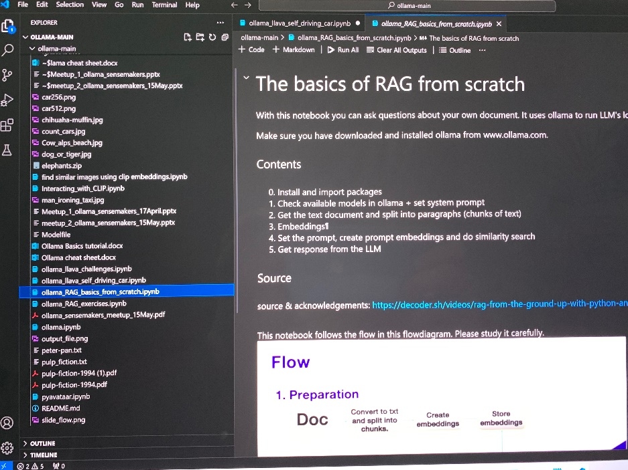

This Jupyter notebook has all the coding you need to do RAG, by start creating vector embeddings of the documents you want to talk to, as to be able to add the relevant pieces to the prompt you’re feeding to the LLM.

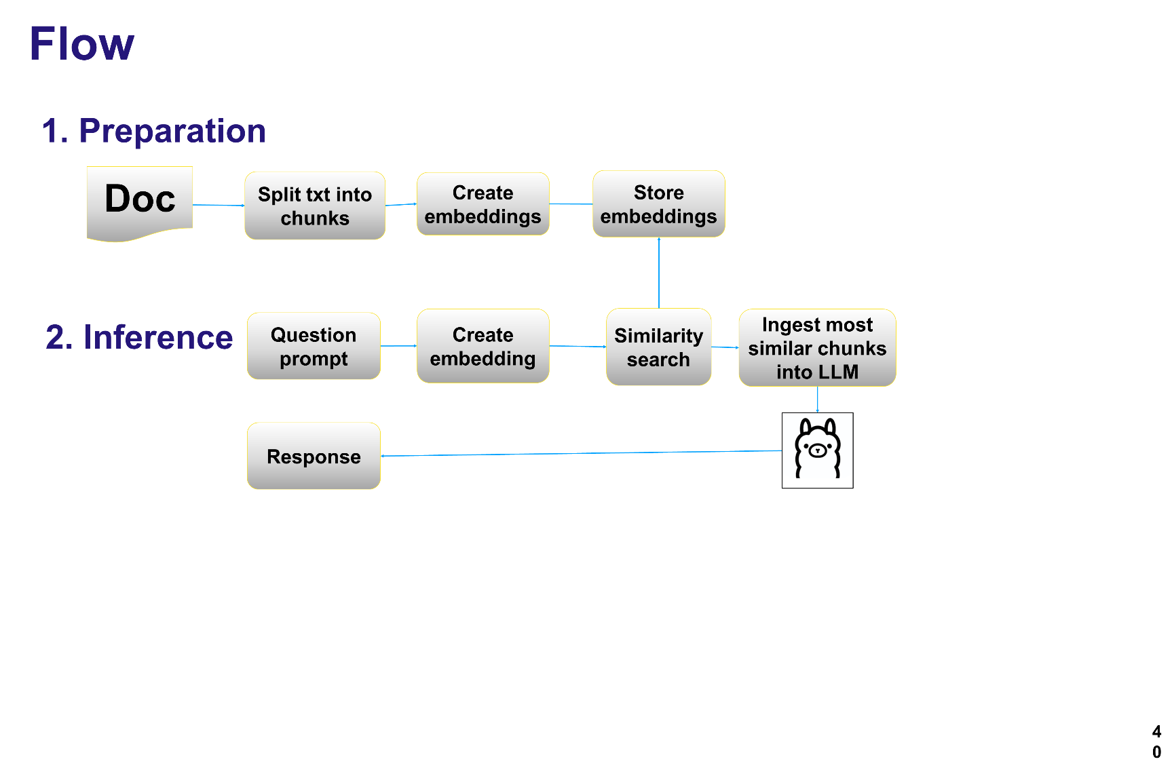For theory & context of RAG, check the presentation: <https://github.com/MichielBbal/ollama/blob/main/meetup_2_ollama_sensemakers_15May.pptx>

Please don’t just run the notebook, also read what’s being done, you’ll need this understanding if you want to move to a next level in the third workshop!! For example you’ll see that a new AI-model, nomic-embed-text is introduced to create the embeddings.

Challenge yourself by trying out different vision challenges, for example

ollama_llava_self_driving_car.ipynb

Also try changing the notebook as to feed it with your own pictures (don’t forget to copy them to the directory where your github-clone **ollama-main** is)